**Enlist and Explain characteristics of cloud computing**

* Cloud is defined as the usage of someone else’s server to host, process or store data.
* Cloud computing is defined as the type of computing where it is the delivery of on-demand computing services over the internet on a pay-as-you-go basis.

Following are the characteristics of cloud computing :

1. On-demand self-services
2. Broad network access
3. Rapid elasticity
4. Resource pooling
5. Measured service
6. Multi-tenancy
7. Virtualization
8. Resilient computing
9. Flexible pricing models.
10. Security
11. Automation
12. Sustainability

* **On-demand self-services:** The Cloud computing services does not require any human administrators, user themselves are able to provision, monitor and manage computing resources as needed.
* **Broad network access:** The Computing services are generally provided over standard networks and heterogeneous devices.
* **Rapid elasticity:** The Computing services should have IT resources that are able to scale out and in quickly and on as needed basis. Whenever the user require services it is provided to him and it is scale out as soon as its requirement gets over.
* **Resource pooling:** The IT resource (e.g., networks, servers, storage, applications, and services) present are shared across multiple applications and occupant in an uncommitted manner. Multiple clients are provided service from a same physical resource.
* **Measured service:** The resource utilization is tracked for each application and occupant, it will provide both the user and the resource provider with an account of what has been used. This is done for various reasons like monitoring billing and effective use of resource.
* **Multi-tenancy:** Cloud computing providers can support multiple tenants (users or organizations) on a single set of shared resources.
* **Virtualization:** Cloud computing providers use virtualization technology to abstract underlying hardware resources and present them as logical resources to users.
* **Resilient computing:** Cloud computing services are typically designed with redundancy and fault tolerance in mind, which ensures high availability and reliability.
* **Flexible pricing models:** Cloud providers offer a variety of pricing models, including pay-per-use, subscription-based, and spot pricing, allowing users to choose the option that best suits their needs.
* **Security:** Cloud providers invest heavily in security measures to protect their users’ data and ensure the privacy of sensitive information.
* **Automation:** Cloud computing services are often highly automated, allowing users to deploy and manage resources with minimal manual intervention.
* **Sustainability:** Cloud providers are increasingly focused on sustainable practices, such as energy-efficient data centers and the use of renewable energy sources, to reduce their environmental impact.

**Compare Grid computing, cluster computing and cloud computing.**

* **A cloud is a network of servers hosted or managed by an external company.** In order to access a cloud service, we typically utilize a website or application.

**Grid computing :**

* Grid computing is defined as a type of computing where it consists of a network of computers that work together to perform tasks that may be difficult for a single machine to handle.
* All the computers on that network work under the same umbrella and are termed as a virtual super computer.
* The tasks they work on is of either high computing power and consist of large data sets.
* All communication between the computer systems in grid computing is done on the “data grid”.

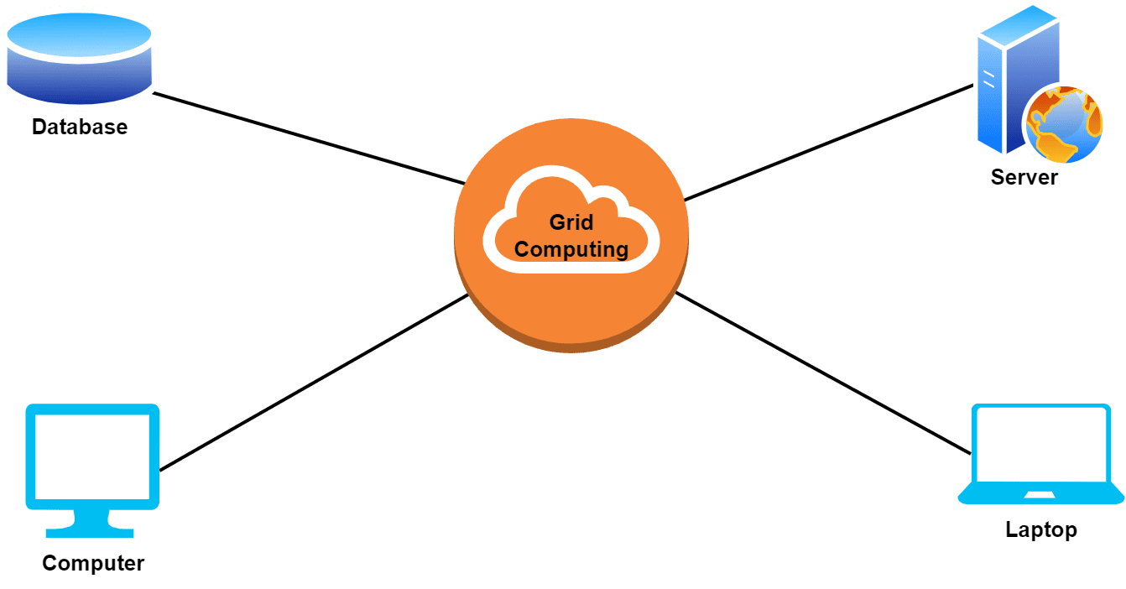

* Grid computing is a form of distributed computing in which a large number of computers are connected via a network to share processing power.
* The grid is managed by a central controller or “master” computer. This master computer divides the task or job into smaller tasks, which are then distributed among the individual computers in the grid.
* The computers then execute the tasks and return the results to the master computer.

**Cluster computing :**

* A cluster is a group of independent computers that work together to perform the tasks given.
* Cluster computing is defined as a type of computing that consists of two or more independent computers, referred to as nodes, that work together to execute tasks as a single machine.
* The goal of cluster computing is to increase the performance, scalability and simplicity of the system.
* The cluster can work with any operating system or architecture. Additionally, **the nodes on the cluster can be synchronous or asynchronous.** Synchronous nodes share data at the same time. Asynchronous nodes send data out at different times.
* This type of computing is often used for large-scale scientific and engineering projects, as the computing power of multiple computers can be harnessed to quickly and accurately solve problems that would otherwise take much longer to solve.
* The benefits of cluster computing include:

1. Increased Performance

2. Cost-Effective

3. Scalability

4. Reliability 5. Flexibility

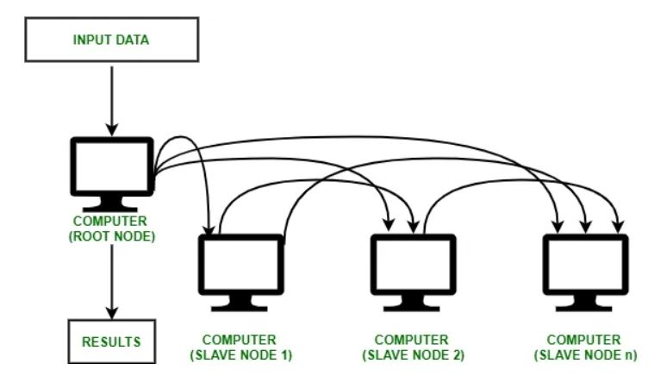

**Cloud Computing :**

* A cloud is a network of servers hosted or managed by an external company. In order to access a cloud service, we typically utilize a website or application.
* Cloud computing is defined as the type of computing where it is the delivery of on-demand computing services over the internet on a pay-as-you-go basis. It is widely distributed, network-based and used for storage.
* Type of cloud are public, private, hybrid and community and some cloud providers are Google cloud, AWS, Microsoft Azure and IBM cloud.
* Generally, there are three main service levels for cloud computing :

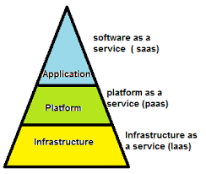

Following are the characteristics of cloud computing :

1. On-demand self-services
2. Broad network access
3. Rapid elasticity
4. Resource pooling
5. Measured service
6. Multi-tenancy
7. Virtualization
8. Resilient computing
9. Flexible pricing models.
10. Security
11. Automation
12. Sustainability

**Describe Pros and Cons of cloud computing**

**Cloud Computing :**

* A cloud is a network of servers hosted or managed by an external company. In order to access a cloud service, we typically utilize a website or application.
* Cloud computing is defined as the type of computing where it is the delivery of on-demand computing services over the internet on a pay-as-you-go basis. It is widely distributed, network-based and used for storage.

Cloud computing has revolutionized business operations by offering a flexible and scalable approach to data management, software deployment, and IT infrastructure. However, like any technology, it comes with both benefits and drawbacks that organizations should consider before adoption.

**Advantages of Cloud Computing**

1. **Data Backup and Restoration**: Cloud computing offers a seamless method for data backup and restoration, ensuring data accessibility even in cases of system failures or data loss.
2. **Improved Collaboration**: Teams can easily share and work together on documents and projects, which enhances productivity and teamwork.
3. **Excellent Accessibility**: With cloud computing, users can access data and applications from anywhere with an internet connection, supporting remote work and flexible operations.
4. **Cost-effective Maintenance**: Organizations save on hardware and software maintenance costs since cloud providers handle updates and infrastructure maintenance.
5. **Automatic Upgrades**: Cloud service providers manage infrastructure updates, security patches, and general maintenance, freeing up IT resources for more strategic tasks.
6. **Mobility**: Cloud computing allows users to access and manage their data from mobile devices, boosting flexibility and productivity.
7. **Pay-per-use Model**: Businesses pay only for the services and resources they use, making it a cost-effective model and allowing better budget management.
8. **Scalable Storage Capacity**: Cloud services offer virtually unlimited storage, catering to the varying data storage needs of businesses.
9. **Enhanced Data Security**: Cloud providers employ advanced security measures like encryption, access controls, and regular audits to protect data.
10. **Disaster Recovery and Business Continuity**: With data redundancy and geographically distributed data centers, businesses can quickly recover from disasters and maintain continuity.
11. **Agility and Innovation**: Cloud computing enables organizations to quickly adopt new technologies, experiment with emerging trends, and foster innovation.
12. **Green Computing**: By optimizing resource use and reducing energy consumption, cloud computing supports environmental sustainability.

**Disadvantages of Cloud Computing**

1. **Vendor Reliability and Downtime**: Cloud service outages, whether due to technical issues, maintenance, or cyberattacks, can disrupt business operations and affect productivity.
2. **Internet Dependency**: Reliable and fast internet connectivity is crucial for accessing cloud services. Connectivity issues can lead to delays and disruptions.
3. **Limited Control and Customization**: Cloud services often come with standard features, limiting an organization’s ability to customize infrastructure and security measures to meet specific needs.
4. **Data Security and Privacy Concerns**: Storing sensitive data in the cloud requires trust in the service provider's security protocols. Data breaches or unauthorized access can result in financial loss and reputational damage.
5. **Hidden Costs and Pricing Models**: While cloud computing reduces upfront costs, additional expenses such as data transfer fees, increased storage, and specialized support can add up.
6. **Dependency on Service Provider**: Relying heavily on a single cloud provider can pose risks if the provider faces financial instability, changes pricing policies, or ceases operations.
7. **Data Location and Compliance**: Cloud data is often stored across multiple data centers worldwide, potentially leading to compliance challenges with data sovereignty and protection regulations

**Draw and Explain Cloud Computing Stack in detail**

* Cloud computing has commonly been referred to as a “stack” because it typically encompasses many different types of services which have been built on top of each other under a “cloud”.
* Cloud computing has been defined by the NIST (National Institute of Standards and Technology) as a model that enables on-demand access to a shared resource pool consisting of servers, networks, applications, services and cloud storage which can be rapidly deployed with minimal management efforts**.**
* There are three different types of cloud computing services namely Platform as a Service or PaaS, Software as a Service or SaaS and Infrastructure as a Service or IaaS.

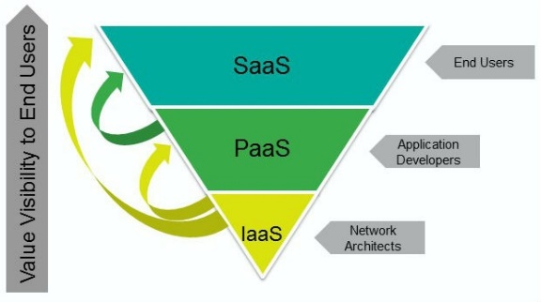

**Software as a service (SaaS)**

* Software as a Service, or SaaS, is simply software that is hosted in the cloud and accessed through the Internet.
* Common examples include Gmail, Twitter, Facebook, Flickr and Dropbox, but software can include accounting, invoicing, tracking sales, planning, performance monitoring, email, instant messaging, marketing etc.
* SaaS is software-on-demand, as we are basically renting software instead of purchasing it.
* With SaaS, a business can simply subscribe to the application, allowing users to access it online from anywhere. Upgrades can occur automatically, so users will always experience the most up-to-date version.

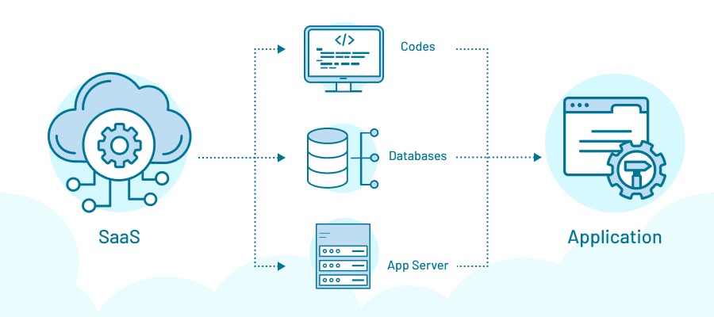

**Platform as a Service (PaaS)**

* Platform as a Service creates a platform and environment for developers to build applications and services.
* The development platform includes operating system, programming language, execution environment, data base and Web server etc.
* The necessary application development tools and services for testing, deploying, collaborating on, hosting and maintaining applications are all supplied by the cloud provider.
* Paas service is like Saas service hosted in the cloud and accessed by users over the Internet.
* It’s a service-based solution, the infrastructure and applications are managed for the customer.
* The PaaS service, like SaaS, is generally paid for on a subscription basis, relying on the usage of the client.
* PaaS creates a platform and environment for developers to build apps and services.

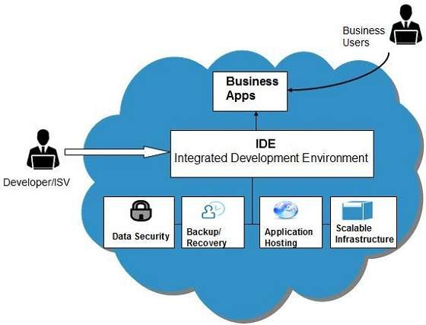

**Infrastructure as a service (IaaS) :**

* Infrastructure as a Service provides computing infrastructure and storage on-demand, via the internet.
* The virtual computing infrastructure includes virtual server space, network connections, bandwidth, IP addresses and load balancers etc.
* Rather than purchasing, installing and integrating new hardware when they need it, clients can simply tap into the cloud resource.
* Physically, the pool of hardware resources is pulled from a multitude of servers and networks usually distributed across numerous data centers, all of which the cloud provider is responsible for maintaining.
* IaaS has subcategories, including public, private and hybrid cloud.
* Public cloud is infrastructure consisting of shared resources, which are deployed over the Internet on a self-service basis.
* Private cloud infrastructure provides the cloud computing features and resources, but on a private network. A combination of these two is called hybrid cloud.

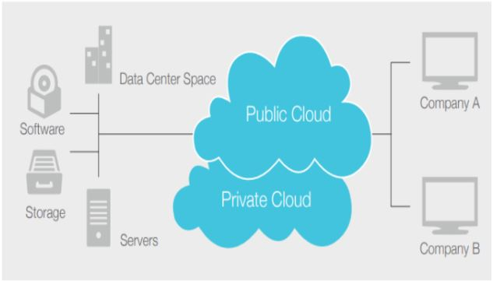

**Illustrate role of networks in cloud computing.**

* A network in the cloud refers to the interconnected infrastructure of servers, [storage](https://www.hpe.com/in/en/storage.html), and applications that are hosted on the internet and made available to users worldwide.
* This network enables users to access and use various computing resources and [services](https://www.hpe.com/in/en/services.html), such as databases, [virtual machines](https://www.hpe.com/in/en/what-is/virtual-machine.html), and applications, without the need for physical infrastructure.
* Networking plays an important role in various aspects of cloud computing:
* Connecting Data Centers
* Delivering Cloud Services
* Securing Cloud Computing Environments

**1. Connecting Data Centers**

Cloud computing providers rely on robust network infrastructure to interconnect their data centers. These networks facilitate data transfer and resource sharing, which are crucial for:

* **High Availability**: Ensuring that cloud services are always accessible, even if one data center fails.
* **Fault Tolerance:** Allowing data centers to back each other up to prevent service interruptions.
* **Scalability:** Enabling the seamless addition of new servers and storage without disrupting existing operations.

**2. Delivering Cloud Services**

Networking is fundamental in delivering cloud services to end-users. Cloud providers use a variety of network technologies, including:

* **Internet:** For general access to cloud services by users globally.
* **Private Networks**: For secure, high-speed connections between enterprise environments and cloud services.
* **Dedicated Connections**: For organizations needing guaranteed bandwidth and low latency.

These networks ensure that users can access cloud services efficiently from any location with minimal delay.

**3.Securing Cloud Computing Environments**

Networking also plays a critical role in the security of cloud computing environments. Cloud providers implement various network-level security measures such as:

* **Firewalls**: To block unauthorized access.
* **Virtual Private Networks (VPNs)**: To create secure communication channels over the internet.
* **Intrusion Detection Systems (IDS)**: To monitor network traffic for suspicious activities.

These measures help protect against unauthorized access, data breaches, and other security threats, ensuring the integrity and confidentiality of data.

**Cloud Computing Protocols**

Cloud computing protocols are standards that define how nodes within a cloud infrastructure communicate. These protocols are essential for ensuring secure and efficient data exchange in cloud environments.

**1. Internet Group Management Protocol (IGMP)**

* **Function**: Facilitates connecting multiple devices to the internet using a single IP address.
* **Usage**: Commonly used in IPv4 networks to initiate multicasting, allowing devices to join existing multicast groups.

**2. Secure Shell Protocol (SSH)**

* **Function**: Provides encrypted communication between computers.
* **Usage**: Widely used for secure remote login and data transfer over unsecured networks.

**3. Converged Enhanced Ethernet Protocol (CEE)**

* **Function**: Standardizes error-free and reliable data transfer between servers, storage devices, and switches.
* **Usage**: Important for storage technology, CEE includes mechanisms for congestion control and management to ensure data integrity.

**4. Connection-less Network Protocol (CLNP)**

* **Function**: Defined by the OSI model as a layer 3 protocol.
* **Usage**: While largely replaced by IP, CLNP is still used in some legacy systems and specific protocol stacks.

**5. Media Transfer Protocol (MTP)**

* **Function**: Developed by Microsoft for synchronizing digital media content between portable devices and PCs.
* **Usage**: Used with portable devices having hard drives, offering an alternative to the Mass Storage Class (MSC) protocol.

**6. State Routing Protocol (SRP)**

* **Function**: One of the primary types of link-state routing protocols.
* **Usage**: Used in network switches (routers) to maintain a network topology map and ensure efficient packet forwarding.

**Differentiate between private and public cloud**

|  |  |  |
| --- | --- | --- |
| **S.No.** | **Public Cloud** | **Private Cloud** |
| 1. | When the computing infrastructure and resources are shared to the public via the internet, it is known as a public cloud. | When the computing infrastructure and the resources are shared to the private network via the internet, it is known as a private cloud. |
| 2. | A public cloud is like a multi-tenant in which the network is managed by your service provider. | A private cloud is like a single-tenant in which the network is handled by the in-house team. |
| 3. | Here the data of several enterprises is stored. | Here the data of a single enterprise is stored. |
| 4. | It supports the activity performed over the public network or internet. | It supports the activity performed over the private network or internet. |
| 5. | The scalability is high in a public cloud. | The scalability is limited in a private cloud. |
| 6. | Reliability is moderate here. | Reliability is high here. |
| 7. | The security depends on the service provider. | It delivers a high class of security. |
| 8. | It is affordable as compared to the private cloud. | It is expensive as compared to the public cloud. |
| 9. | In the public cloud, the performance is low to medium. | The performance is high in a private cloud. |
| 10. | It covers the shared servers. | It covers the devoted servers. |

**What are deployment models in cloud ?**

* Cloud Deployment Model functions as a virtual computing environment with a deployment architecture that varies depending on the amount of data you want to store and who has access to the infrastructure.
* Different types of cloud computing deployment models are :

1. Public Cloud
2. Private Cloud
3. Hybrid Cloud
4. Community Cloud

**Public cloud :**

* Public Cloud provides a shared platform that is accessible to the general public through an Internet connection.
* Public cloud operated on the pay-as-per-use model and administrated by the third party, i.e., Cloud service provider.
* In the Public cloud, the same storage is being used by multiple users at the same time.
* Public cloud is owned, managed, and operated by businesses, universities, government organizations, or a combination of them.
* Amazon Elastic Compute Cloud (EC2), Microsoft Azure, IBM's Blue Cloud, Sun Cloud, and Google Cloud are examples of the public cloud.

**Benefits of Public Cloud**

* Minimal Investment - As a pay-per-use service, there is no large upfront cost and is ideal for businesses who need quick access to resources
* No Hardware Setup - The cloud service providers fully fund the entire Infrastructure
* No Infrastructure Management - This does not require an in-house team to utilize the public cloud.

**Private Cloud**

* Private cloud is also known as an internal cloud or corporate cloud.
* Private cloud provides computing services to a private internal network (within the organization) and selected users instead of the general public.
* Private cloud provides a high level of security and privacy to data through firewalls and internal hosting. It also ensures that operational and sensitive data are not accessible to third-party providers.
* HP Data Centers, Microsoft, Elastra-private cloud, and Ubuntu are the example of a private cloud.

**Advantages of Private cloud**

1) More Control

Private clouds have more control over their resources and hardware than public clouds because it is only accessed by selected users.

2) Security & privacy

Security & privacy are one of the big advantages of cloud computing. Private cloud improved the security level as compared to the public cloud.

3) Improved performance

Private cloud offers better performance with improved speed and space capacity.

**Hybrid Cloud :**

* Hybrid cloud is a combination of public and private clouds.

**Hybrid cloud = public cloud + private cloud**

* The main aim to combine these cloud (Public and Private) is to create a unified, automated, and well-managed computing environment.
* In the Hybrid cloud, non-critical activities are performed by the public cloud and critical activities are performed by the private cloud.
* Mainly, a hybrid cloud is used in finance, healthcare, and Universities.
* The best hybrid cloud provider companies are Amazon, Microsoft, Google, Cisco, and NetApp.

**Benefits of Hybrid Cloud :**

* Cost-Effectiveness - The overall cost of a hybrid solution decreases since it majorly uses the public cloud to store data.
* Security - Since data is properly segmented, the chances of data theft from attackers are significantly reduced.
* Flexibility - With higher levels of flexibility, businesses can create custom solutions that fit their exact requirements

**Community Cloud**

* It allows systems and services to be accessible by a group of organizations.
* It is a distributed system that is created by integrating the services of different clouds to address the specific needs of a community, industry, or business.
* The infrastructure of the community could be shared between the organization which has shared concerns or tasks.
* It is generally managed by a third party or by the combination of one or more organizations in the community.

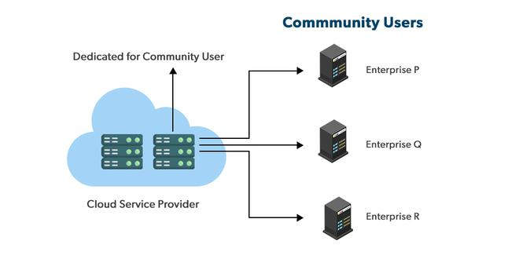

**Advantages of the Community Cloud Model**

* **Cost Effective:**It is cost-effectivebecause the cloud is shared by multiple organizations or communities.
* **Security:** Community cloud provides better security.
* **Shared resources:**It allows you to share resources, infrastructure, etc. with multiple organizations.
* **Collaboration and data sharing:**It is suitable for both collaboration and data sharing.

**Illustrate role of web services in cloud computing**

* Web services play a crucial role in cloud computing by providing a mechanism for applications and systems to communicate and interact with each other over the internet.
* They enable the creation, deployment, and consumption of services in a distributed environment.
* Key roles of web services in cloud computing :

**1. Service Provisioning**

Web services allow cloud providers to offer their services to clients or other applications. These services can range from:

* **Infrastructure Resources**: Such as virtual machines, storage, and databases.
* **Higher-level Services**: Like messaging, queuing, authentication, etc.

By offering standardized interfaces and protocols, web services enable seamless access to and utilization of these cloud services.

**2. Service Discovery**

* Web services facilitate the discovery of available services in the cloud.
* Through mechanisms like service registries or service directories, clients or applications can locate and identify the services they need.
* This enables dynamic service composition and integration, where different services can be combined to create more complex applications or workflows.

**3. Interoperability**

* Web services enable interoperability between different systems and platforms.
* They employ standard protocols which include:
* XML (eXtensible Markup Language),
* SOAP (Simple Object Access Protocol)
* REST (Representational State Transfer)
* This promotes integration and collaboration across diverse environments.

**4. Scalability and Elasticity**

* Cloud-based web services can be designed to scale horizontally or vertically based on demand.

**Horizontal Scaling**:

* Also known as scaling out, involves adding more instances of a service, such as adding more servers to handle increased demand.
* For example, a web application can distribute its traffic load across multiple servers, ensuring that no single server is overwhelmed.

**Distributed Computing:**

* Web services are easily portable over different platforms and can be implemented on different server instances so that issues with load balancing and failovers can be easily addressed.

**5. Security and Authentication**

* Web services provide mechanisms to enforce security and authentication in cloud environments.
* Web services often use **HTTPS (HTTP Secure)** to encrypt data transmitted over the internet. This protocol ensures that data is securely transmitted between the client and the server, preventing unauthorized access during transmission.
* **WS-Security** is a standard for securing web services messages using XML-based protocols. It provides message integrity, confidentiality, and authentication.
* **OAuth** is a protocol that allows secure, token-based authentication and authorization. It enables users to grant third-party applications limited access to their resources without exposing credentials.

**6. Integration and Legacy System Connectivity**

* Web services play a crucial role in bridging cloud-based services with existing on-premises or legacy systems, ensuring seamless connectivity and data exchange.

**APIs as Web Services:**

* By exposing internal functionalities as APIs (Application Programming Interfaces), organizations can securely connect their legacy systems with modern cloud services.

**Write a short note on: • Infrastructure as Services (IaaS) • Platform as a Services (PaaS) • Software as a Services (SaaS)**

**Software as a service (SaaS)**

* Software as a Service, or SaaS, is simply software that is hosted in the cloud and accessed through the Internet.
* Common examples include Gmail, Twitter, Facebook, Flickr and Dropbox, but software can include accounting, invoicing, tracking sales, planning, performance monitoring, email, instant messaging, marketing etc.
* SaaS as software-on-demand, as we are basically renting software instead of purchasing it.
* With SaaS, a business can simply subscribe to the application, allowing users to access it online from anywhere. Upgrades can occur automatically, so users will always experience the most up-to-date version.



**Platform as a Service (PaaS)**

* Platform as a Service creates a platform and environment for developers to build applications and services.
* The development platform includes operating system, programming language, execution environment, data base and Web server etc.
* The necessary application development tools and services for testing, deploying, collaborating on, hosting and maintaining applications are all supplied by the cloud provider.
* Paas service is like Saas service hosted in the cloud and accessed by users over the Internet.
* It’s a service-based solution, the infrastructure and applications are managed for the customer.
* The PaaS service, like SaaS, is generally paid for on a subscription basis, relying on the usage of the client.
* PaaS creates a platform and environment for developers to build apps and services.



**Infrastructure as a service (IaaS) :**

* Infrastructure as a Service provides computing infrastructure and storage on-demand, via the internet.
* The virtual computing infrastructure includes virtual server space, network connections, bandwidth, IP addresses and load balancers etc.
* Rather than purchasing, installing and integrating new hardware when they need it, clients can simply tap into the cloud resource.
* Physically, the pool of hardware resources is pulled from a multitude of servers and networks usually distributed across numerous data centers, all of which the cloud provider is responsible for maintaining.
* IaaS has subcategories, including public, private and hybrid cloud.
* Public cloud is infrastructure consisting of shared resources, which are deployed over the Internet on a self-service basis.

Private cloud infrastructure provides the cloud computing features and resources, but on a private network. A combination of these two is called hybrid cloud.

